Name Surname:Furkan ÖZER Date:10/11/2025
Number:2023555067 Report No:05
Digital Design Lab Report
Homework / Lab
Parts of Report:
Description:
- Design a 4x1 Mux for given function with VHDL codes. Simplify the Function. Explain how to make compilation and simulation. Show the simulation results. F(A,B,C)=Σm(1,3,5,6)
2.Design a 3 to 8 decoder.
- Truth Table of Design (4x1 mux)
A (Data) | B(Selection) | C(Selection) | Y
0 | 0 | 0 | 0
0 | 0 | 1 | 1
0 | 1 | 0 | 0
0 | 1 | 1 | 1
1 | 0 | 0 | 0
1 | 0 | 1 | 1
1 | 1 | 0 | 1
1 | 1 | 1 | 0

2.Truth Table of Design (3x8 decoder)
_{A2} | _{A1} | _{A0} | _{Y7} | _{Y6} | _{Y5} | _{Y4} | _{Y3} | _{Y2} | _{Y1} | _{Y0}
0 | 0 | 0 | 0 | 0 | 0 | 0 | 0 | 0 | 0 | 1
0 | 0 | 1 | 0 | 0 | 0 | 0 | 0 | 0 | 1 | 0
0 | 1 | 0 | 0 | 0 | 0 | 0 | 0 | 1 | 0 | 0
0 | 1 | 1 | 0 | 0 | 0 | 0 | 1 | 0 | 0 | 0
1 | 0 | 0 | 0 | 0 | 0 | 1 | 0 | 0 | 0 | 0
1 | 0 | 1 | 0 | 0 | 1 | 0 | 0 | 0 | 0 | 0
1 | 1 | 0 | 0 | 1 | 0 | 0 | 0 | 0 | 0 | 0
1 | 1 | 1 | 1 | 0 | 0 | 0 | 0 | 0 | 0 | 0

- Drawing the circuit of desired desing
a.4x1 Multiplexer’s Circuit

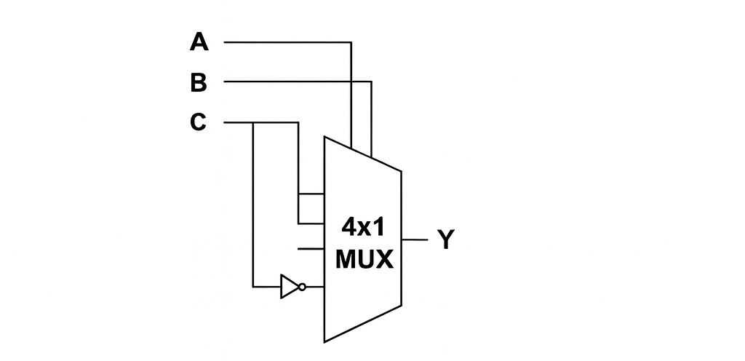

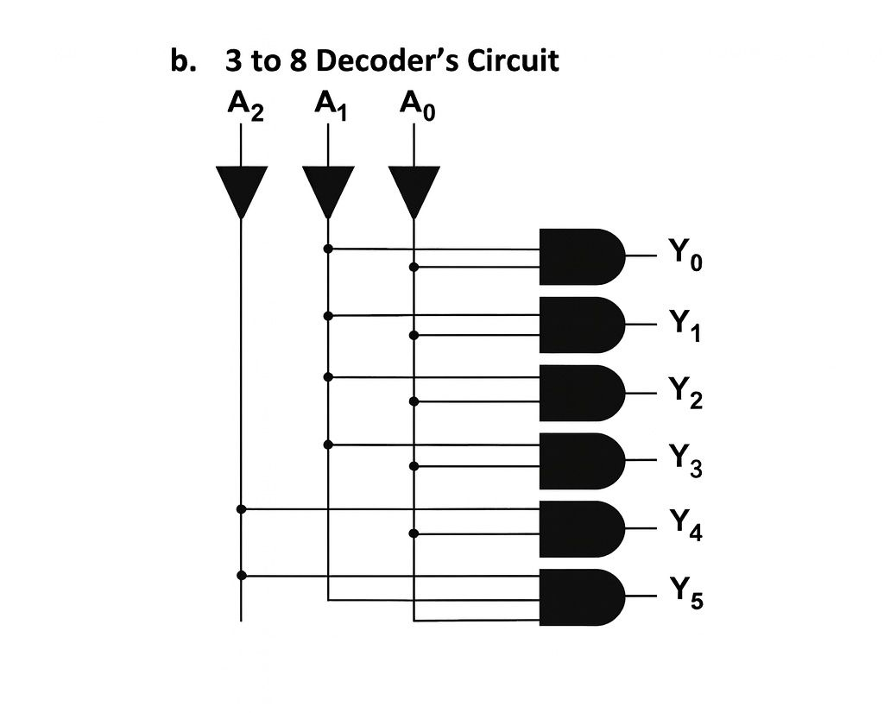

- Steps of Lab/Homework:
a.4x1 Multiplexer’s Code:
library IEEE;
use IEEE.std_logic_1164.ALL;

entity mux_funk is
port(

A:in STD_LOGIC;
B:in STD_LOGIC;
C:in STD_LOGIC;
Y:out STD_LOGIC);
end mux_fonk;

architecture mimari of mux_fonk is
begin
process (A,B,C) is
begin
if (B='0' and C='0') then
Y<='0';
elsif (B='0' and C='1')then
Y<='1';
elsif (B='1' and C='0') then
Y<=A;
elsif (B='1' and C='1') then
Y<=not A;
else Y<='0';
end if;
end process;
end mimari;

b.3x8 Decoder’s Code:
library ieee;
use ieee.std_logic_1164.all;

entity decoder is
port(
A: in std_logic_vector(0 to 2);
Y: out std_logic_vector(0 to 7)
);
end entity decoder;

architecture mimari of decoder is
begin
with A select
Y <= "00000001" when "000",
"00000010" when "001",
"00000100" when "010",
"00001000" when "011",
"00010000" when "100",
"00100000" when "101",
"01000000" when "110",
"10000000" when "111",
"00000000" when others;
end architecture mimari;

Simulation Results:
a.4x1 Multiplexer’s Simulation Result:

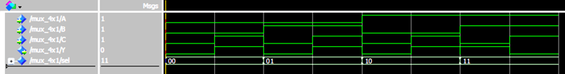

b.3x8 Decoder’s Simulation Result:

- Conclusion:
In this laboratory experiment, a 4x1 MUX implementing the function F(A,B,C)=Σm(1,3,5,6) and a standard 3-to-8 decoder were successfully designed using VHDL. The truth tables constructed for both circuits were confirmed to be consistent with the corresponding VHDL implementations. Simulation results verified that each circuit performed correctly and fully met the expected logical behavior defined by their truth tables.

